**SCREEN SHOTS**

FEEDBACK.POM.XML

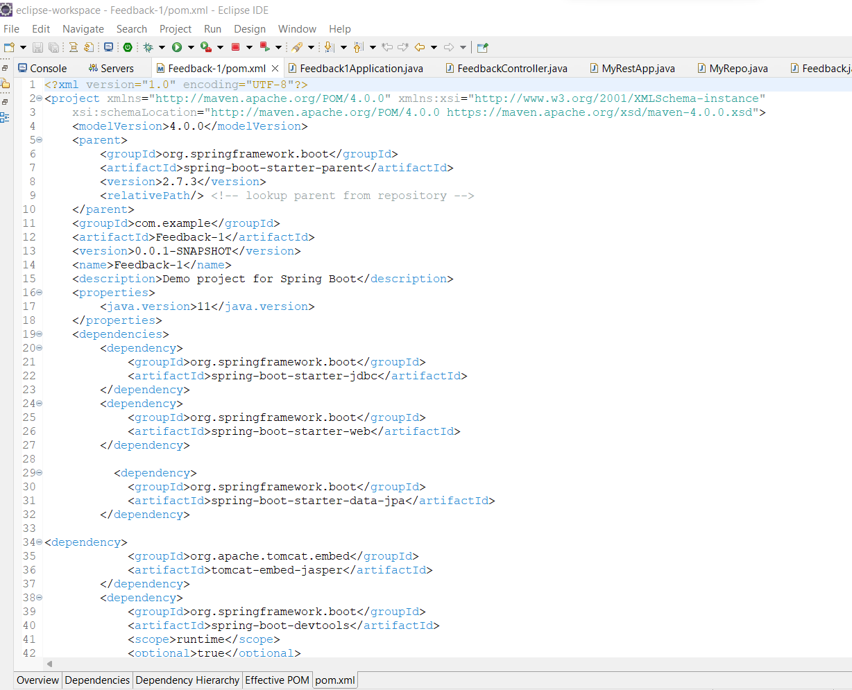

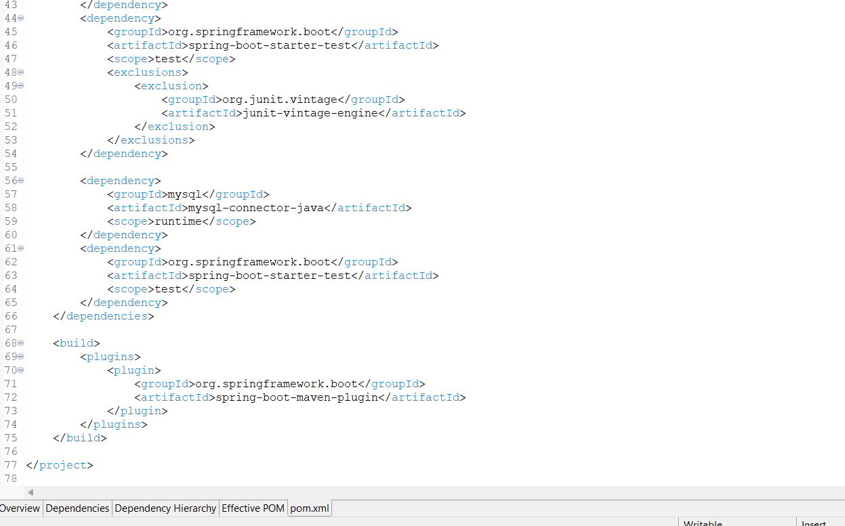

Feeback1 Application.java

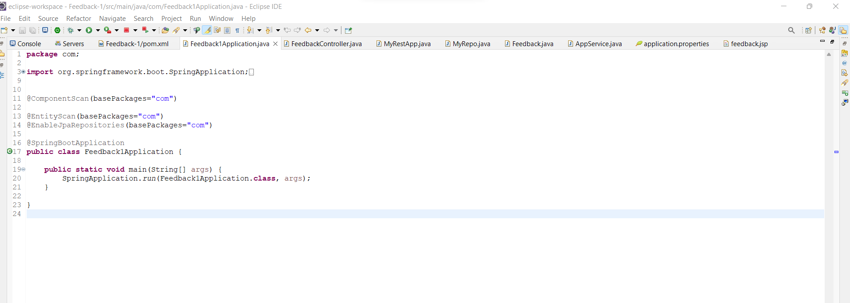

Feedbackcontroller.java

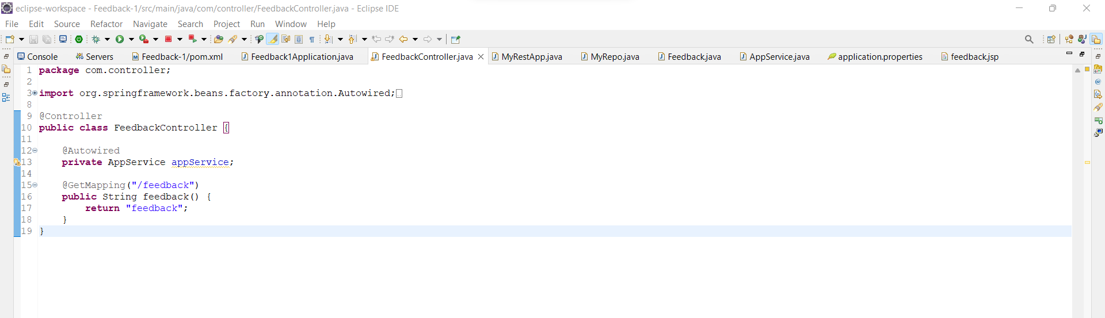

MyRest.java

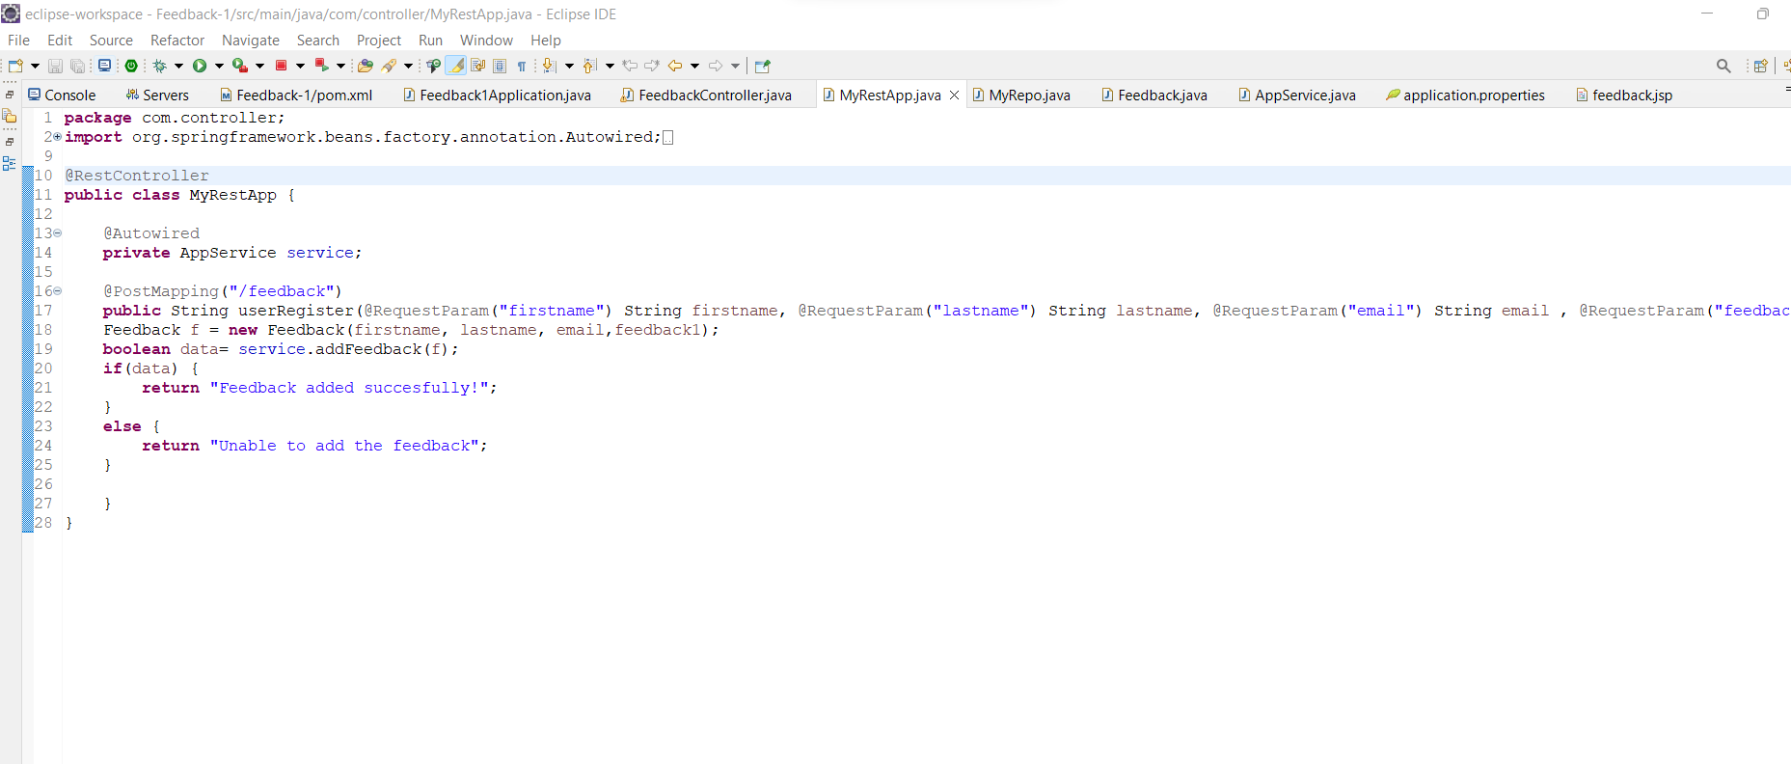

MyRepo.java

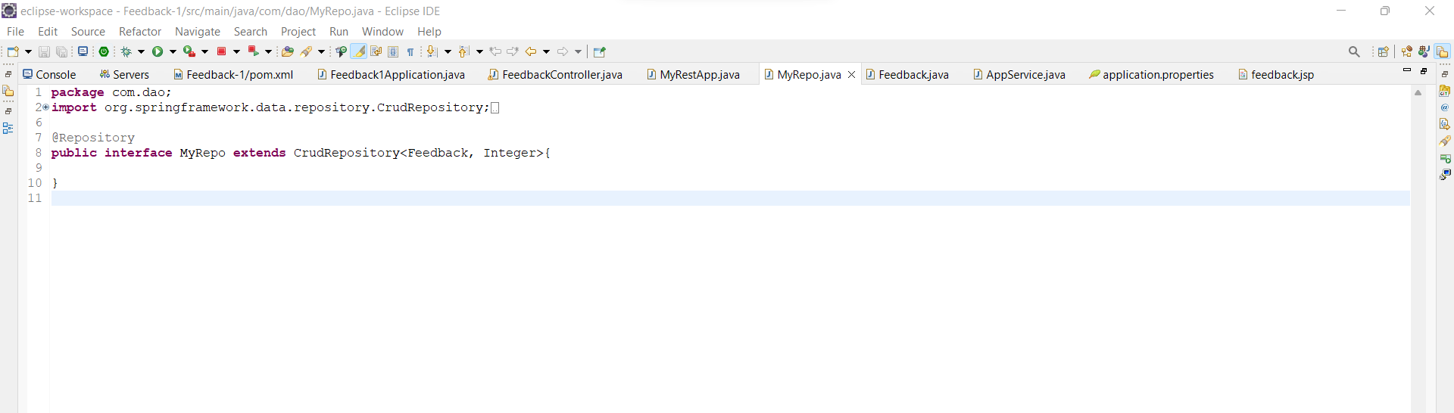

Feedback.java

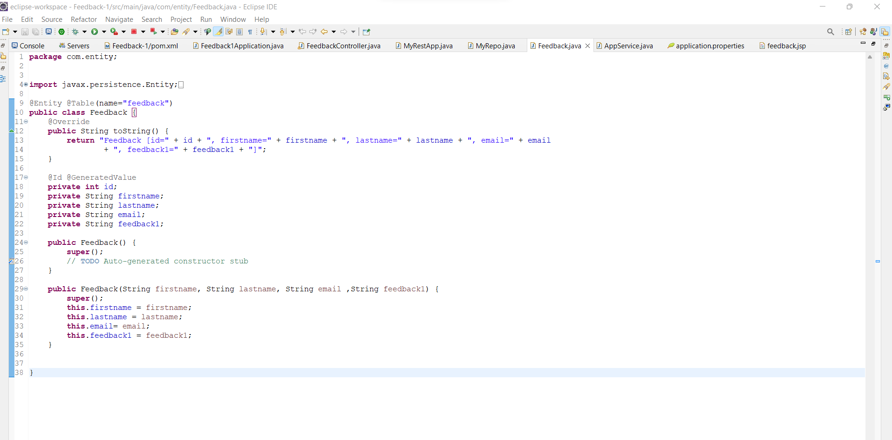

AppService.java

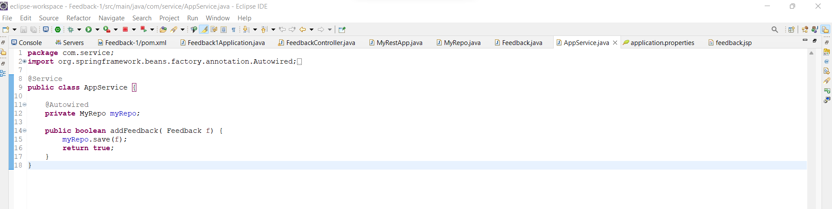

Application Properties

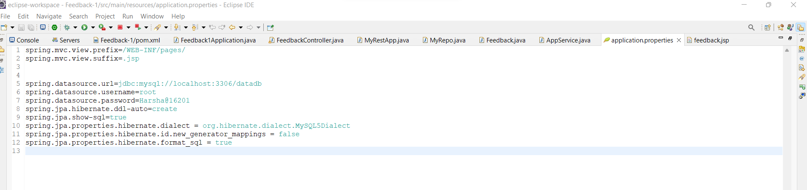

feedback.jsp

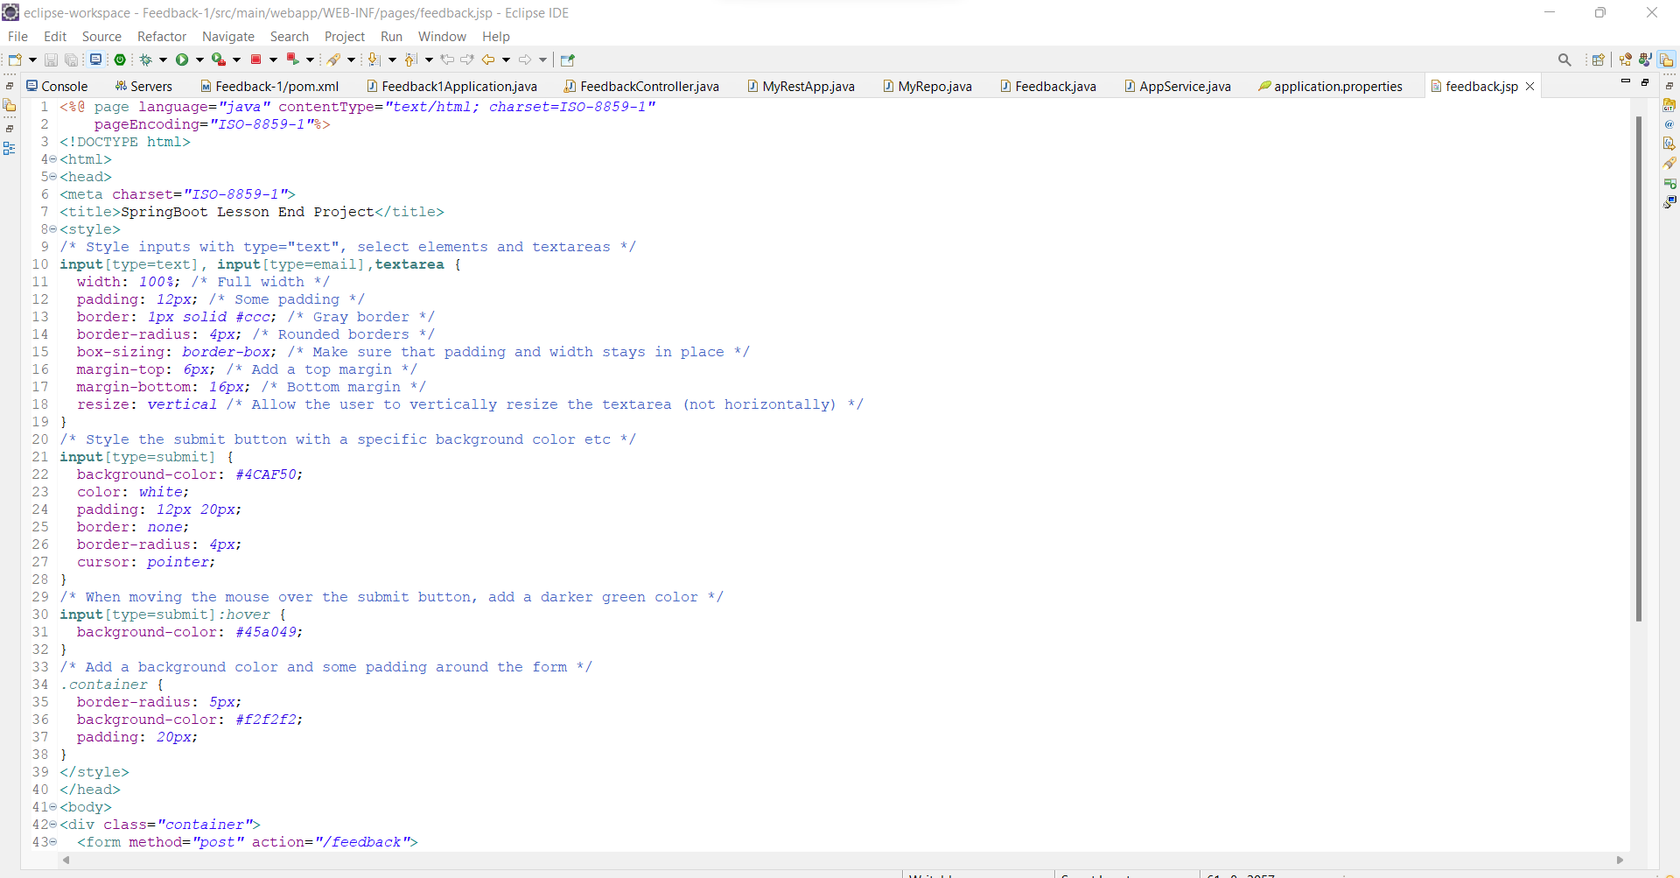

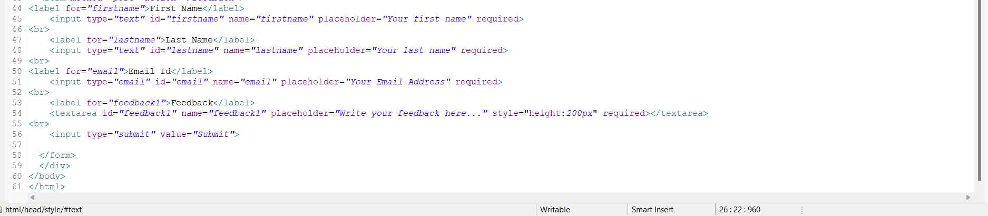

Output in Browser:

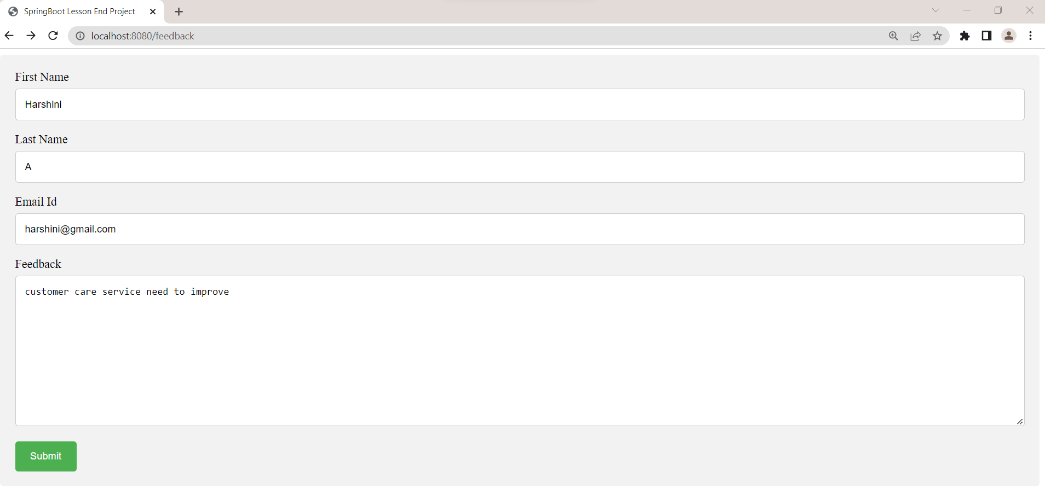

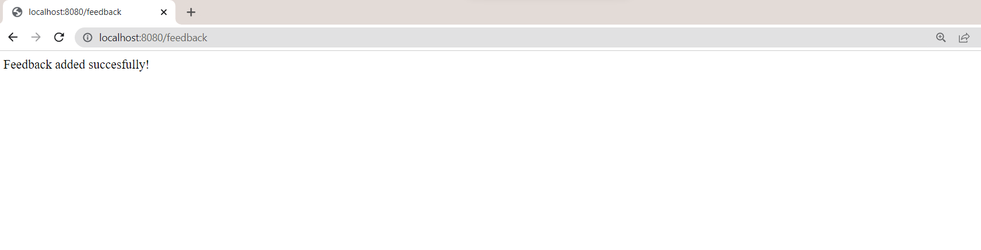

Console:

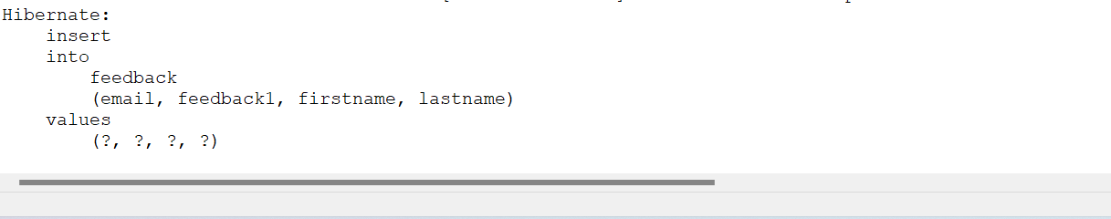

MySQL output:

